Question:
Write a Hospital Management System program using Kotlin.
Aim:
To develop a Hospital Management System using Kotlin that allows the user to admit patients, display the list of patients, and discharge patients through a menu-driven interface.
Program:
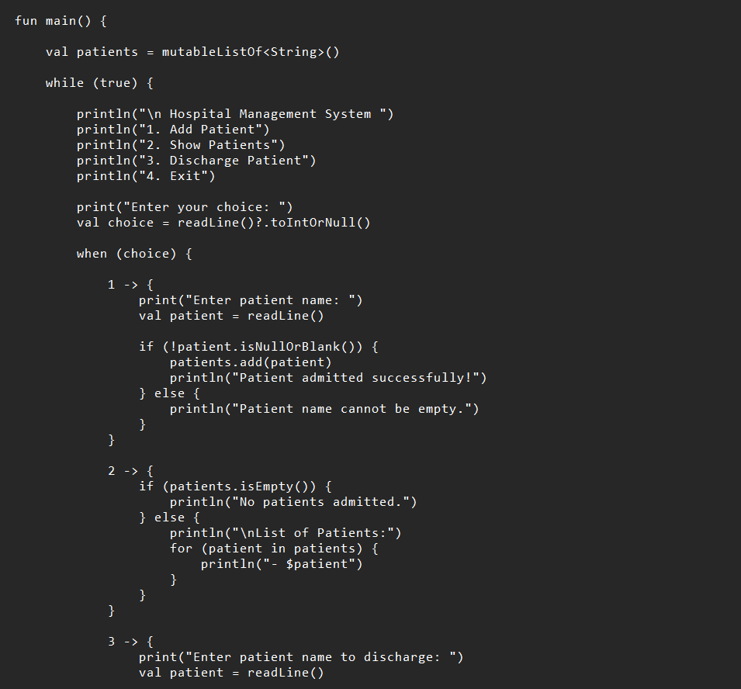

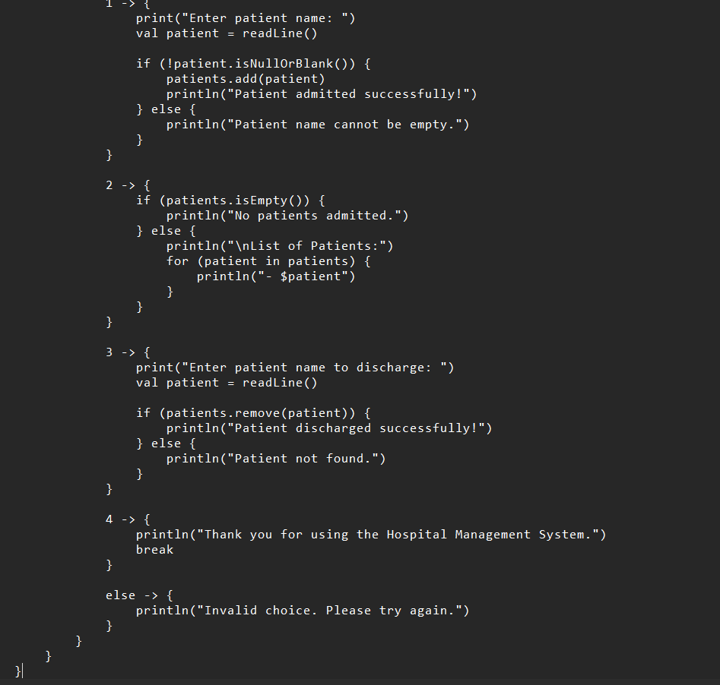

Output:
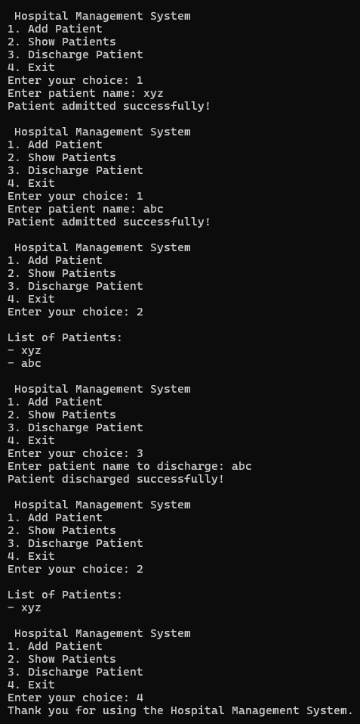
Conclusion:
The above program has been executed successfully

